**Here is the order processing issues for** [**walcart.com**](http://walcart.com) **:**

* **Environment:**
  1. OS: Windows 10 Pro
  2. Testing Date: 24/sep/2022
  3. Browser : Version 105.0.5195.127 (Official Build) (64-bit)
  4. Display Resolution : 1920 * 1080
* **Issue number 1:**
* **Steps:**

1. Go to <https://www.walcart.com/>
2. Go to a product details page
3. Click on “Add to Cart”
4. Click on “View Cart”
5. Took to “https://www.walcart.com/checkout/cart/”

* **Actual Result:** 
  1. Arrow up and down icon besides the quantity is not visible without hover.
* **Expected Result:**
  1. Arrow up and down icon besides the quantity should be always visible.

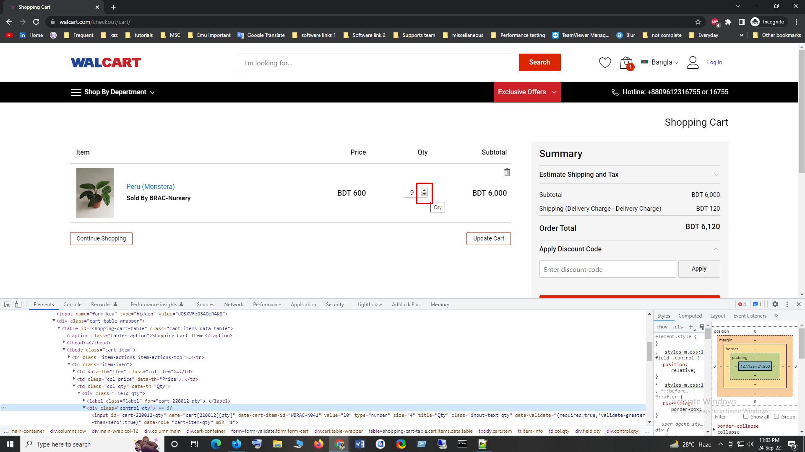

* **Issue number 2:**
* **Steps:**
  1. dd Go to <https://www.walcart.com/>
  2. Go to a product details page
  3. Click on “Add to Cart”
  4. Click on “View Cart”
  5. Took to “https://www.walcart.com/checkout/cart/”
* **Actual Result:** 
  1. Page loaded, but data not loaded properly.
* **Expected Result:**
  1. Page should show contents after all the data load.

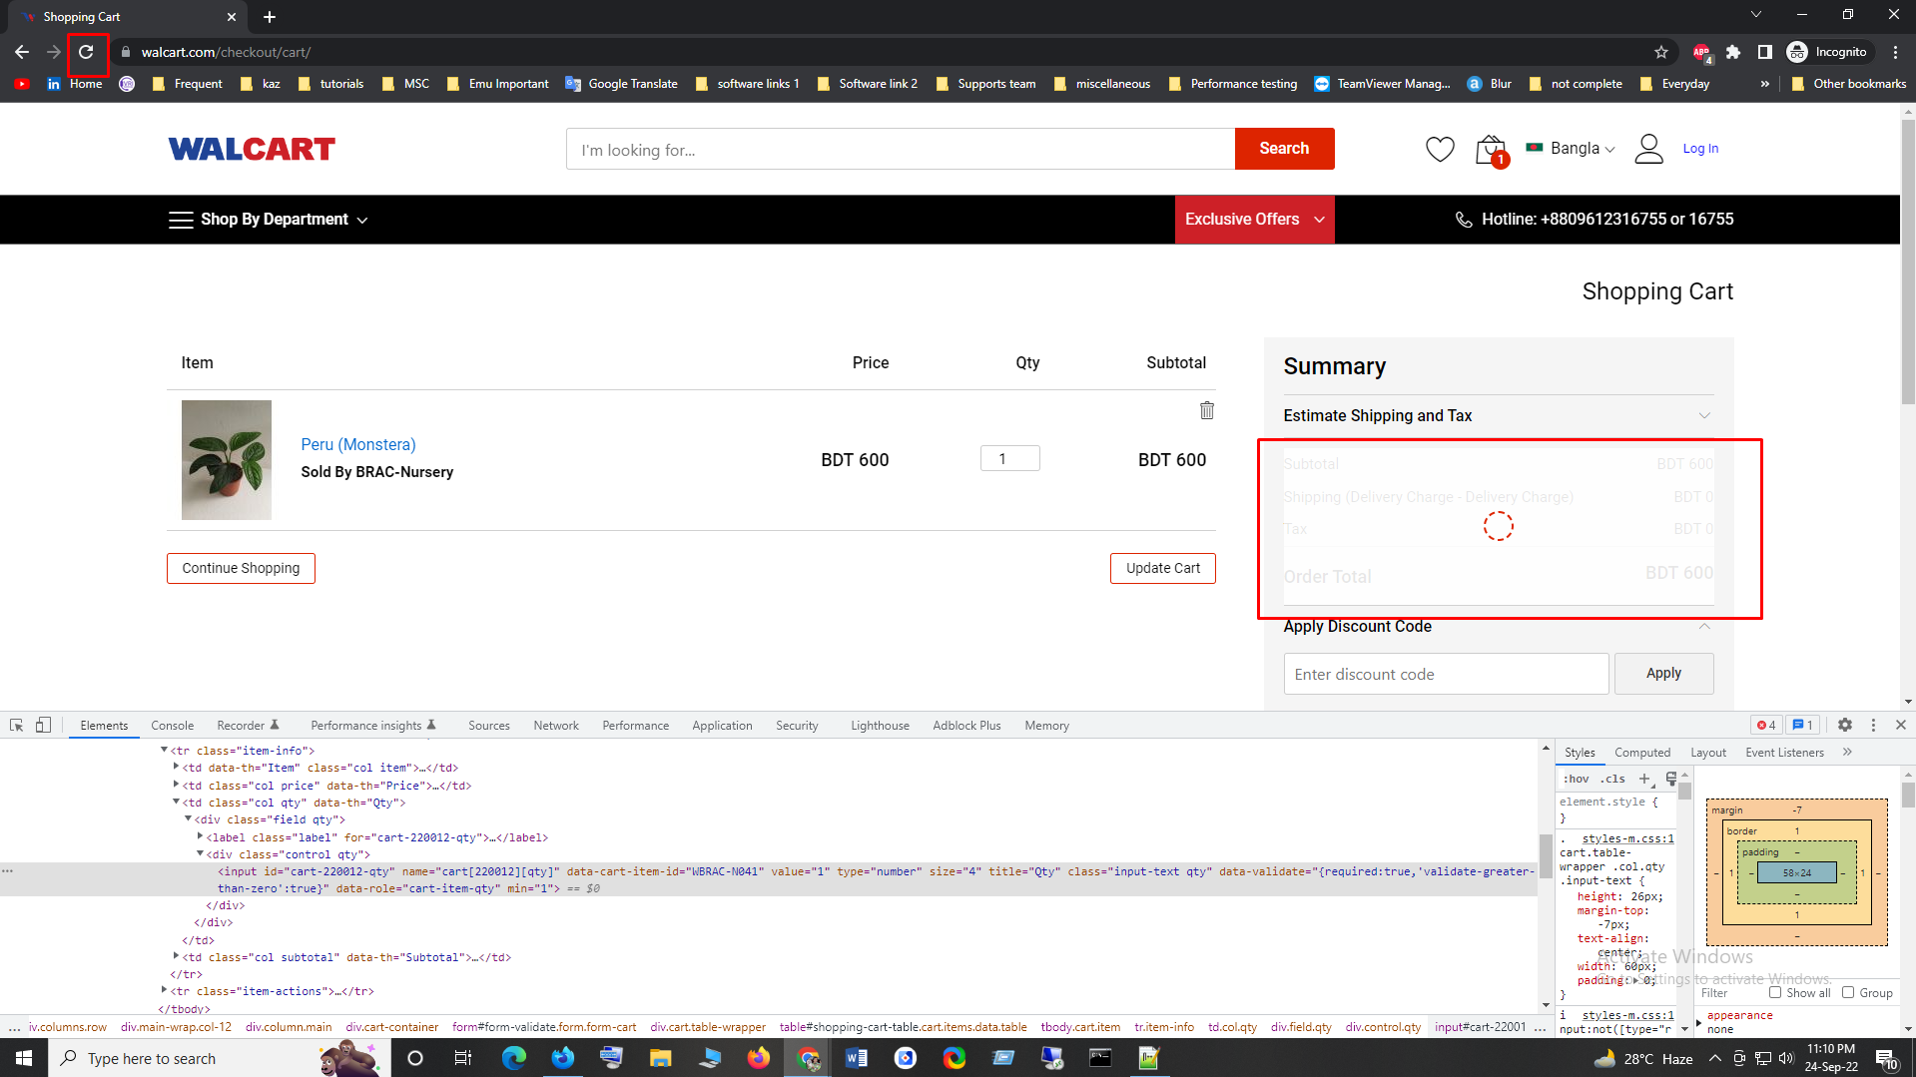

* **Issue number 3:**
* **Steps:**
  1. Go to <https://www.walcart.com/>
  2. Go to a product details page
  3. Click on “Add to Cart”
  4. Click on “View Cart”
  5. Took to <https://www.walcart.com/checkout/cart/>
  6. Scroll down, page ends,
* **Actual Result:** 
  1. But it continuously takes to the upper part of the page, though I am scrolling down.
  2. <https://gyazo.com/12ee3a3098e1e0b2ba35b139fe946812>
* **Expected Result:**
  1. Scroll should work properly.
* **Issue number 4:**
* **Steps:**
  1. Go to <https://www.walcart.com/>
  2. Go to a product details page
  3. Click on “Add to Cart”
  4. Click on “View Cart”
  5. Took to <https://www.walcart.com/checkout/cart/>
  6. Click on “Proceed to Checkout”
  7. Took to “LOGIN / SIGN UP” page
* **Actual Result:** 
  1. If I am a guest user, why should I login?
* **Expected Result:**
  1. If I am a guest user, login should not be required.
  2. Should take to <https://www.walcart.com/checkout/#shipping> page

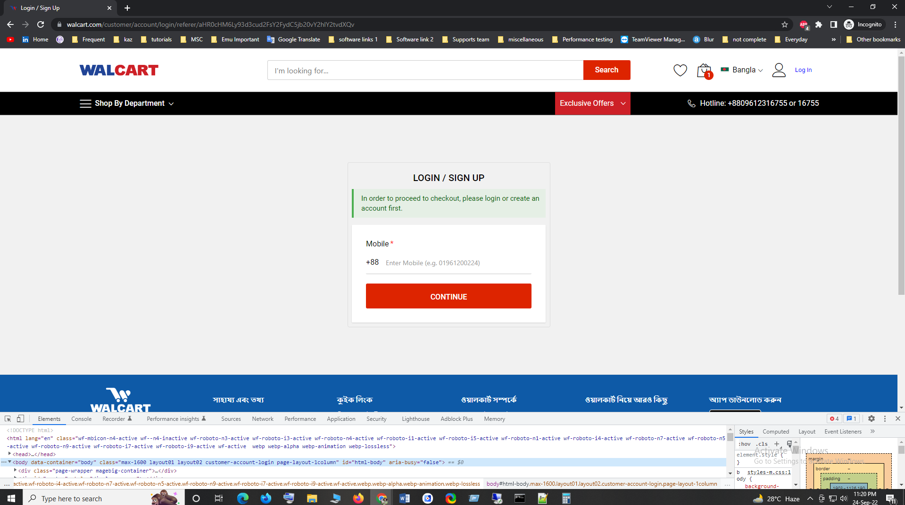

* **Issue number 5:**
* **Steps:**
  1. Go to <https://www.walcart.com/>
  2. Go to a product details page
  3. Click on “Add to Cart”
  4. Click on “View Cart”
  5. Took to <https://www.walcart.com/checkout/cart/>
  6. Click on “Proceed to Checkout”
  7. Took to “LOGIN / SIGN UP” page
  8. Input mobile number
  9. Press continue
  10. Took to the registration page
* **Actual Result:** 
  1. Not have resend OTP option
* **Expected Result:**
  1. Should have resend OTP option

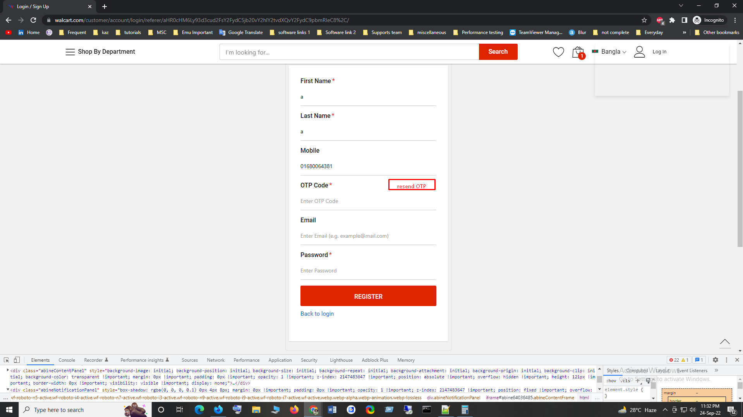

* **Issue number 6:**
* **Steps:**
  1. Go to <https://www.walcart.com/>
  2. Go to a product details page
  3. Click on “Add to Cart”
  4. Click on “View Cart”
  5. Took to <https://www.walcart.com/checkout/cart/>
  6. Click on “Proceed to Checkout”
  7. Took to “LOGIN / SIGN UP” page
  8. Input mobile number
  9. Press continue
  10. Took to the registration page
  11. Fill up all the fields
  12. Add space with the OTP code
* **Actual Result:** 
  1. Not have trim to remove the space
* **Expected Result:**
  1. Should have trim to remove the space

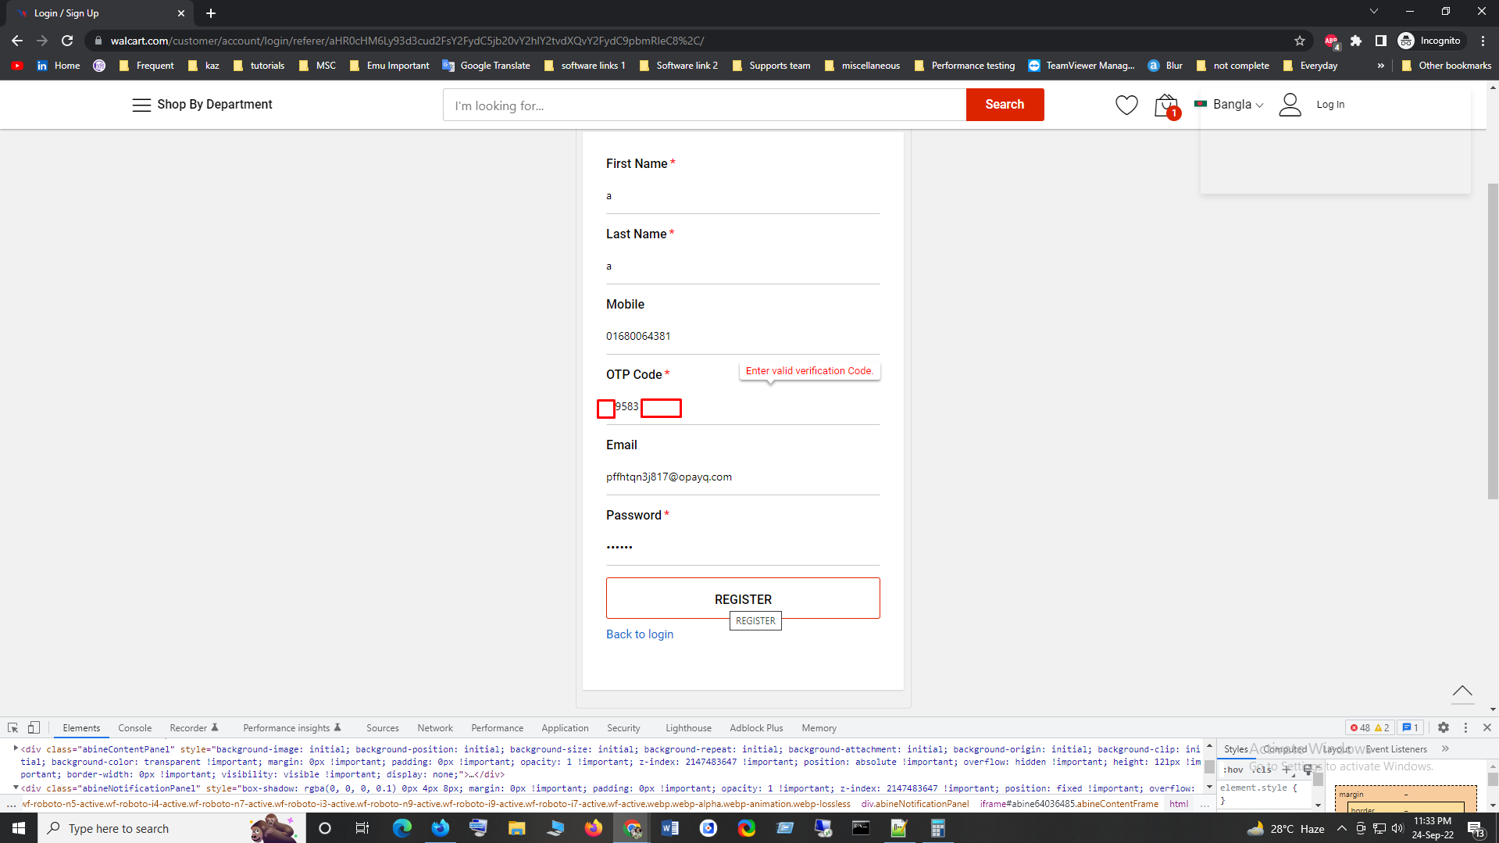

* **Issue number 7:**
* **Steps:**
  1. Go to <https://www.walcart.com/>
  2. Go to a product details page
  3. Click on “Add to Cart”
  4. Click on “View Cart”
  5. Took to <https://www.walcart.com/checkout/cart/>
  6. Click on “Proceed to Checkout”
  7. Took to “LOGIN / SIGN UP” page
  8. Input mobile number
  9. Press continue
  10. Took to the registration page
  11. Fill up all the fields
  12. Press “Register” button
  13. Took to next page https://www.walcart.com/checkout/#shipping
* **Actual Result:** 
  1. Can add "-" into phone number
* **Expected Result:**
  1. Should not add "-" into phone number

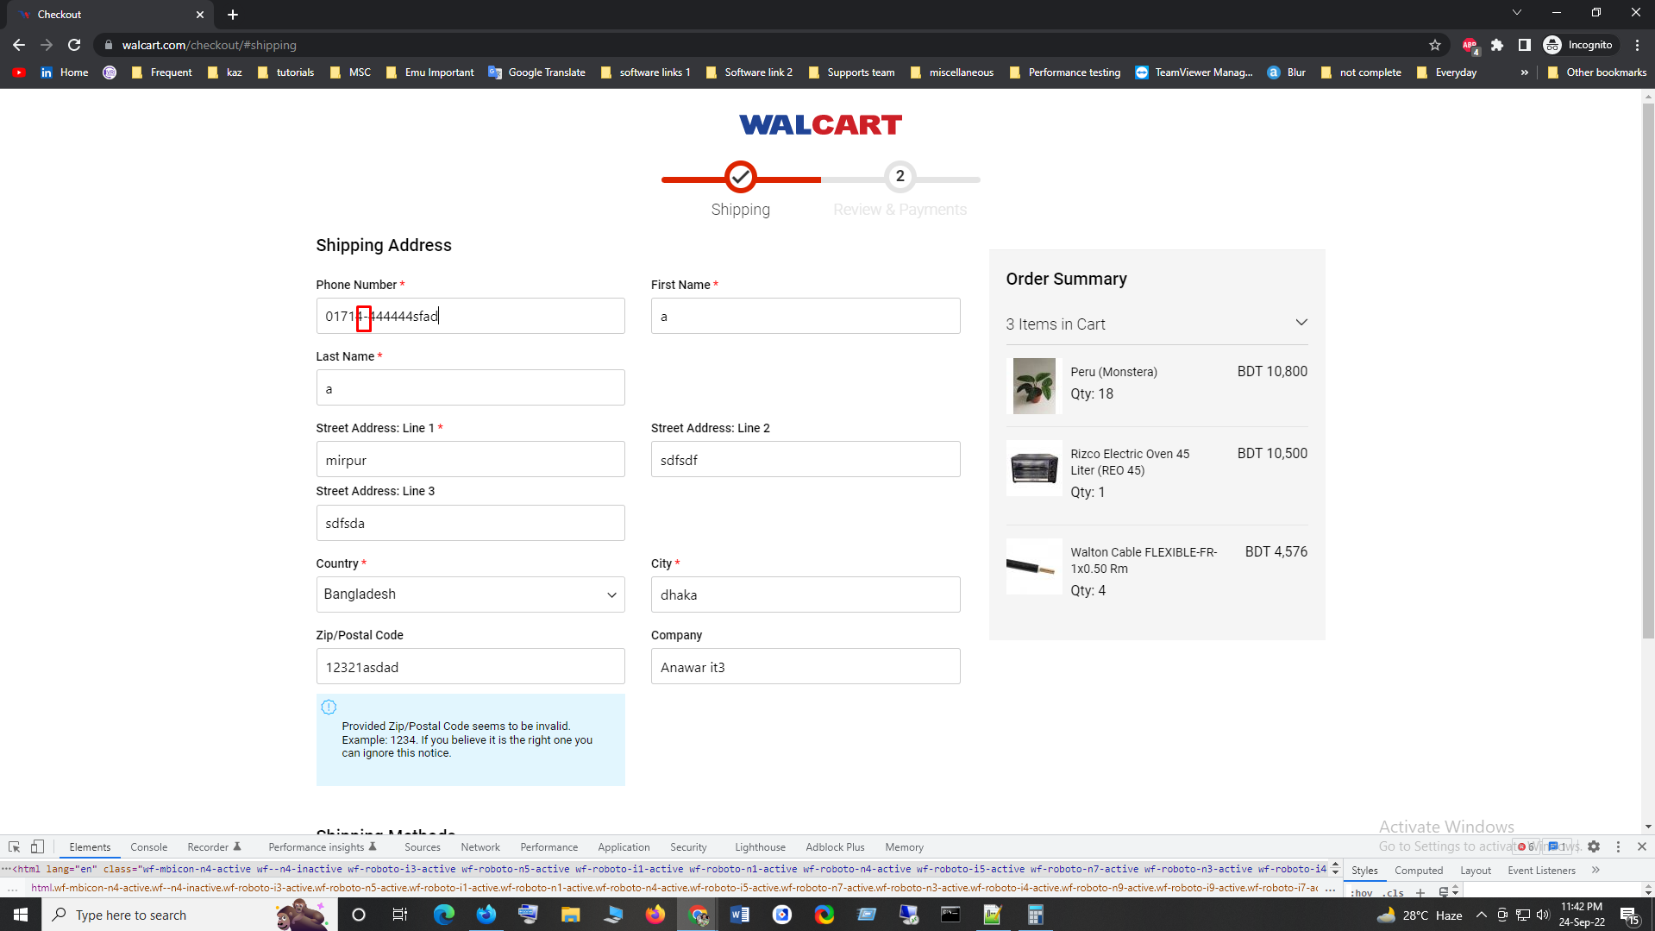

* **Issue number 8:**
* **Steps:**
  1. Go to <https://www.walcart.com/>
  2. Go to a product details page
  3. Click on “Add to Cart”
  4. Click on “View Cart”
  5. Took to <https://www.walcart.com/checkout/cart/>
  6. Click on “Proceed to Checkout”
  7. Took to “LOGIN / SIGN UP” page
  8. Input mobile number
  9. Press continue
  10. Took to the registration page
  11. Fill up all the fields
  12. Press “Register” button
  13. Took to next page <https://www.walcart.com/checkout/#shipping>
* **Actual Result:** 
  1. Not have a option "back to Cart" from this page
* **Expected Result:**
  1. Should have an option "back to Cart" from this page

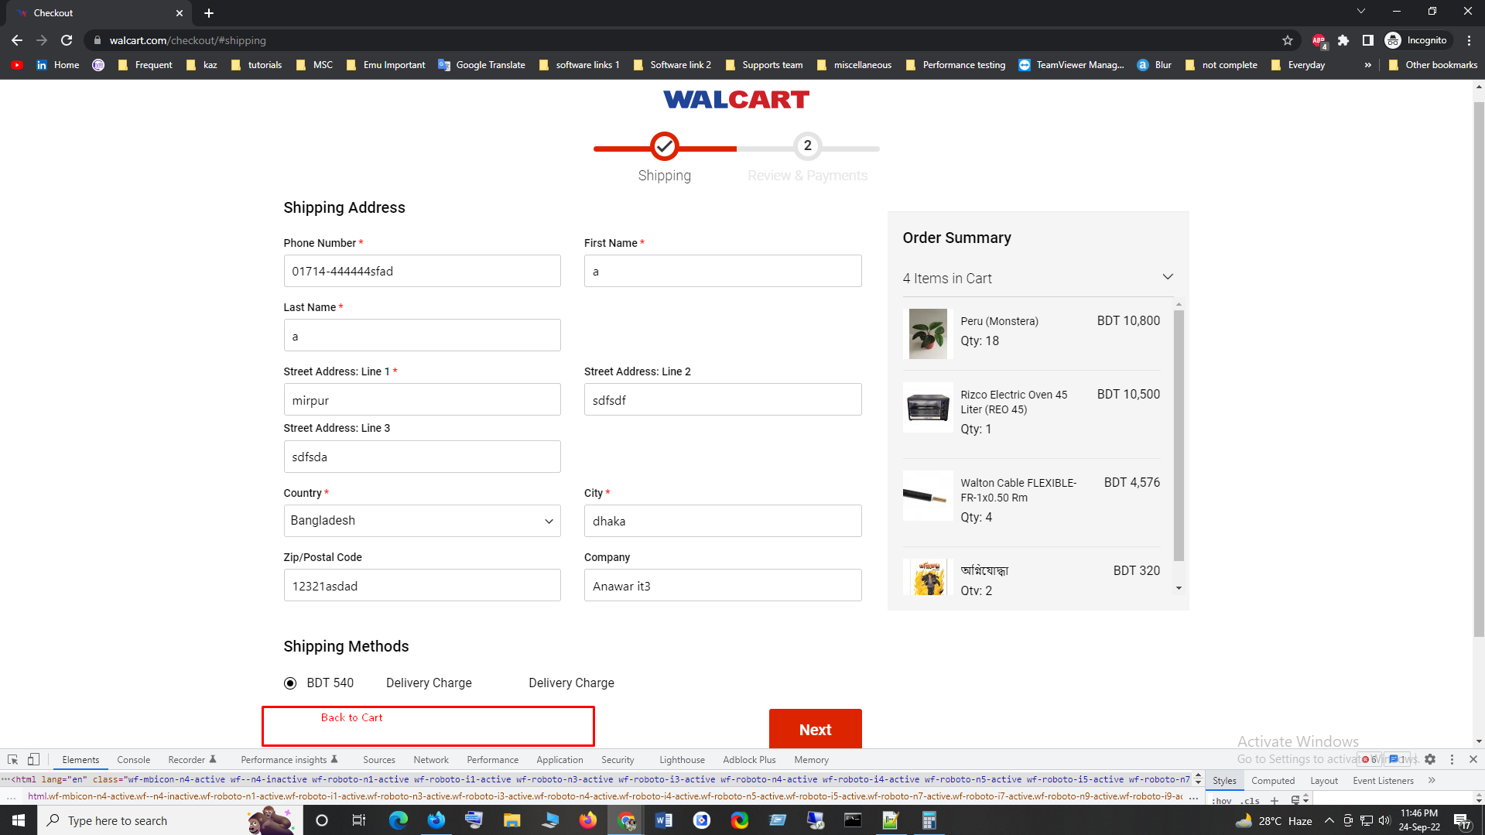

* **Issue number 9:**
* **Steps:**
  1. Go to <https://www.walcart.com/>
  2. Go to a product details page
  3. Click on “Add to Cart”
  4. Click on “View Cart”
  5. Took to <https://www.walcart.com/checkout/cart/>
  6. Click on “Proceed to Checkout”
  7. Took to “LOGIN / SIGN UP” page
  8. Input mobile number
  9. Press continue
  10. Took to the registration page
  11. Fill up all the fields
  12. Press “Register” button
  13. Took to next page <https://www.walcart.com/checkout/#shipping>
* **Actual Result:** 
  1. Delivery charge is showing multiple times
  2. Not have the option to select Shipping Method
* **Expected Result:**
  1. Delivery charge Should show only one time for appropriate Shipping Method
  2. Should not show Delivery charge word.

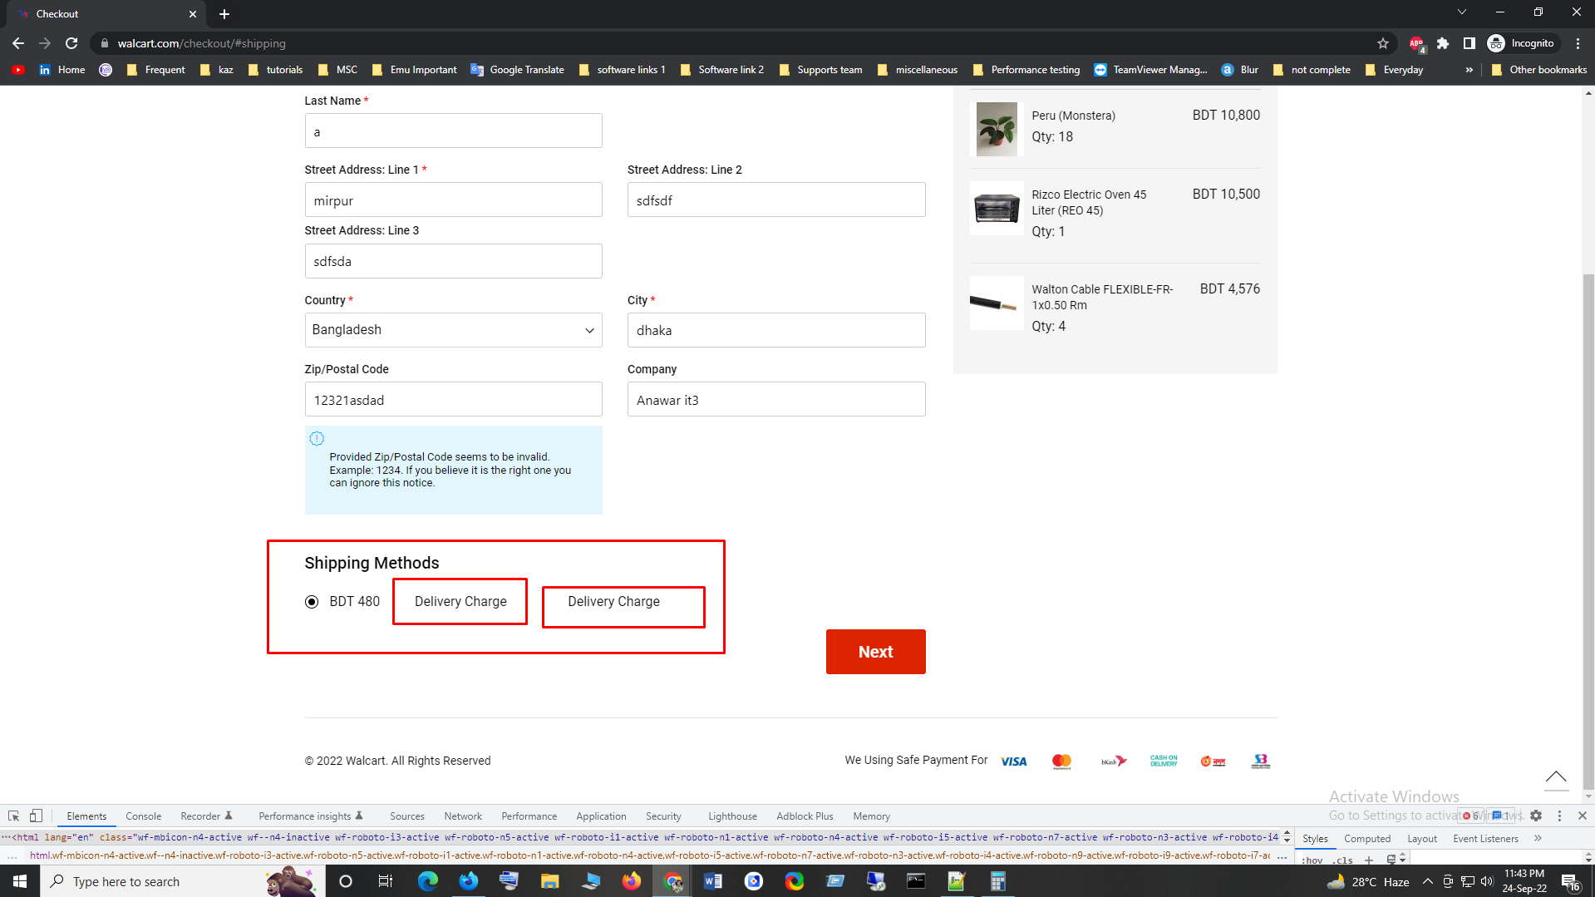

* **Issue number 10:**
* **Steps:**
  1. Go to <https://www.walcart.com/>
  2. Go to a product details page
  3. Click on “Add to Cart”
  4. Click on “View Cart”
  5. Took to <https://www.walcart.com/checkout/cart/>
  6. Click on “Proceed to Checkout”
  7. Took to “LOGIN / SIGN UP” page
  8. Input mobile number
  9. Press continue
  10. Took to the registration page
  11. Fill up all the fields
  12. Press “Register” button
  13. Took to next page <https://www.walcart.com/checkout/#shipping>
* **Actual Result:** 
  1. Ui issue, all words 1st letter is not capital
  2. <https://prnt.sc/xrTK-aYr5uc1>
* **Expected Result:**
  1. All words 1st letter should be capital.

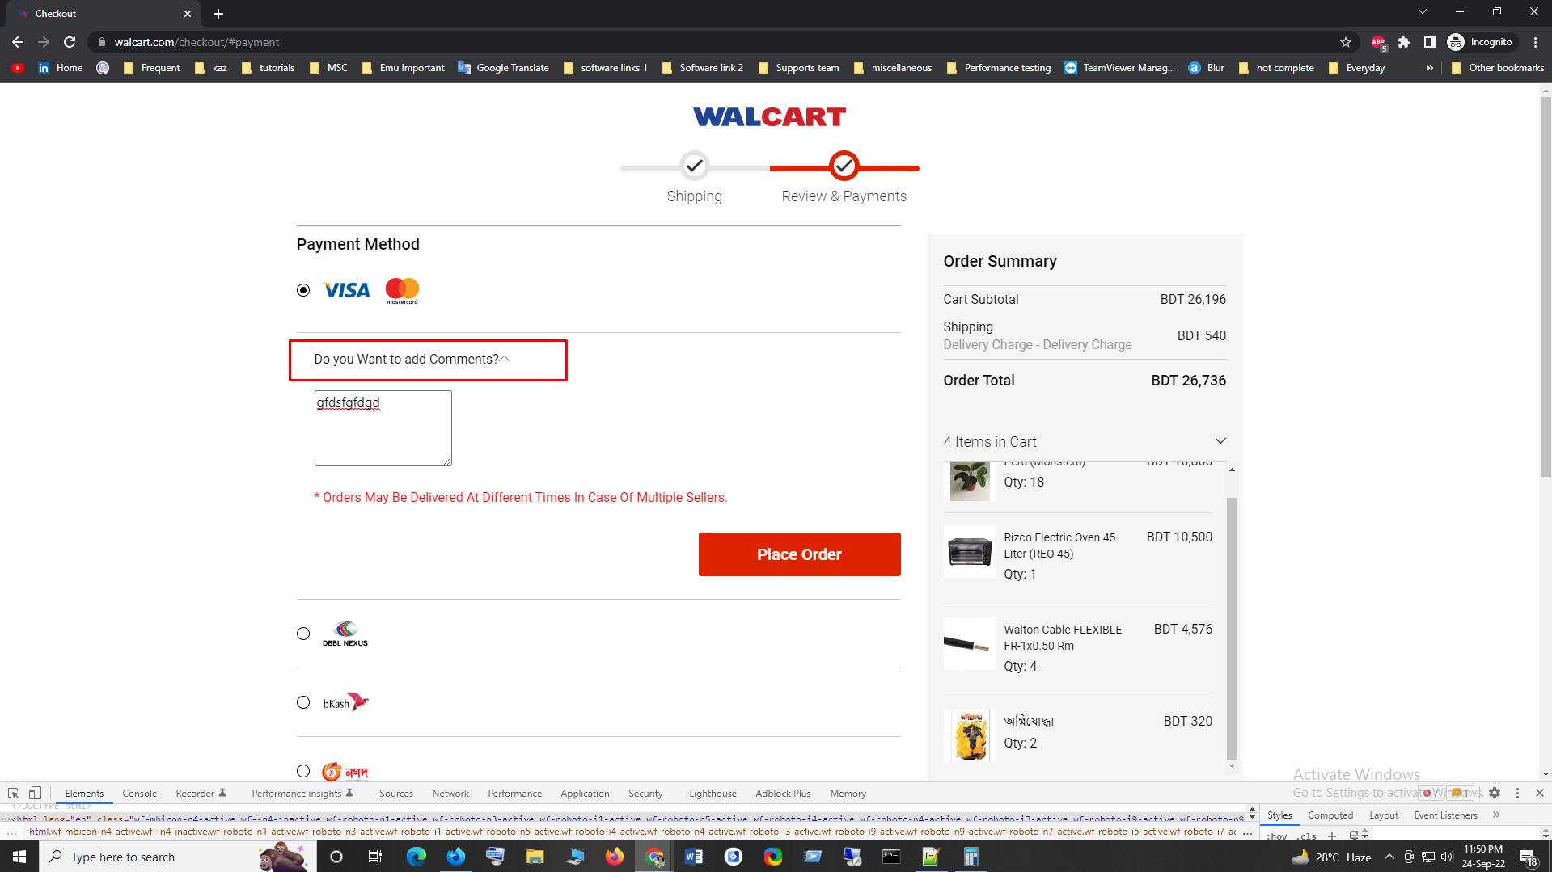

* **Issue number 11:**
* **Steps:**
  1. Go to <https://www.walcart.com/>
  2. Go to a product details page
  3. Click on “Add to Cart”
  4. Click on “View Cart”
  5. Took to <https://www.walcart.com/checkout/cart/>
  6. Click on “Proceed to Checkout”
  7. Took to “LOGIN / SIGN UP” page
  8. Input mobile number
  9. Press continue
  10. Took to the registration page
  11. Fill up all the fields
  12. Press “Register” button
  13. Took to next page <https://www.walcart.com/checkout/#shipping>
  14. payment canceled
  15. Click on “View Cart”

* **Actual Result:** 
  1. Payment canceled, not have the option to revert previous orders
  2. <https://gyazo.com/c992089cf00cf7f833a579a7cc909065>
* **Expected Result:**
  1. If payment canceled, should have the option to revert previous orders

